-- Group #9

-- Group Members: Chi Ming Lai / Chao Liu / Chirag Mudgil

-- cmlai@myseneca.ca / cliu155@myseneca.ca/ [cmudgil@myseneca.ca](mailto:cmudgil@myseneca.ca)

Cpp file functions part for Chi Ming Lai

1. Find account

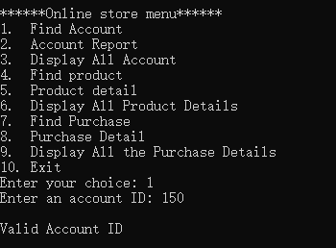

2. Account report

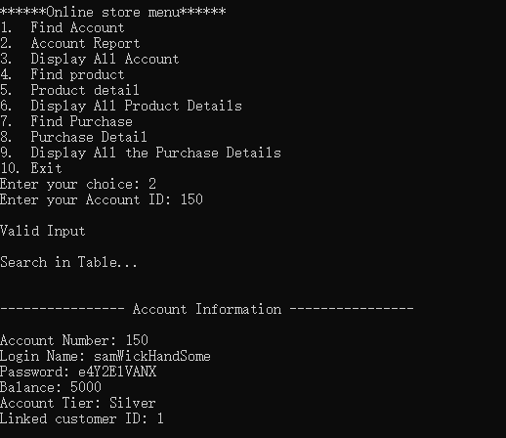

3. Display all account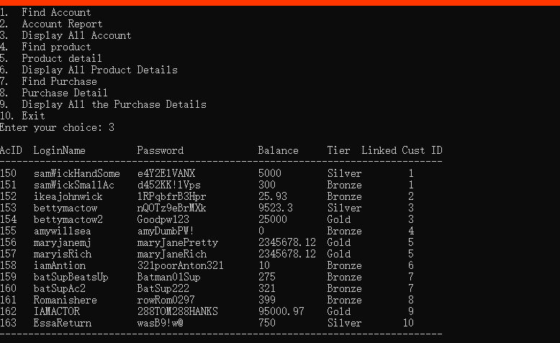

4. Add account

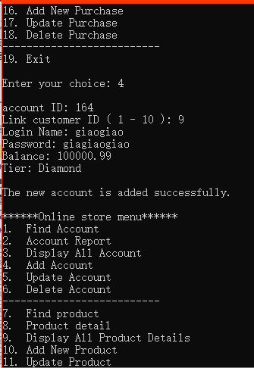

5. Update Account

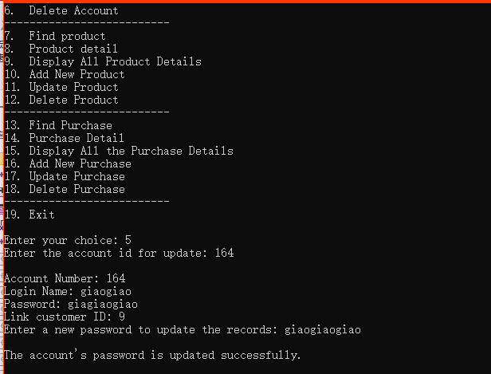

6. Delete Account

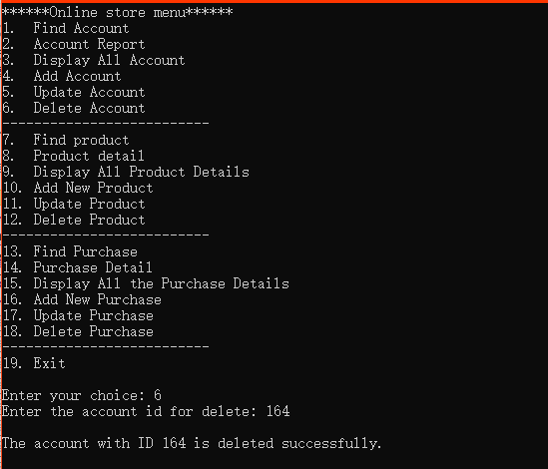

Cpp file functions part for Chao Liu

7. Find product

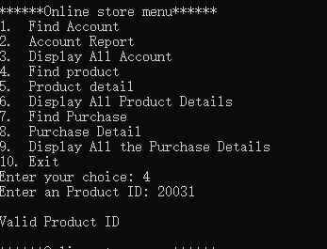

8. Product detail

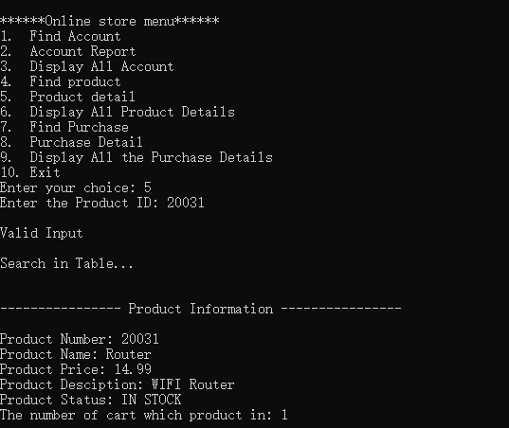

9. Display all product details

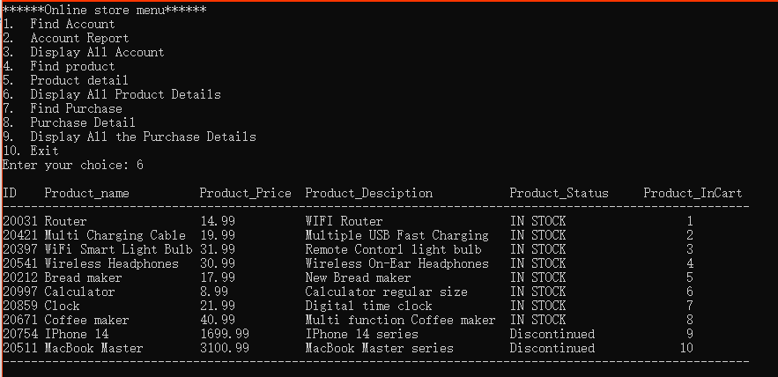

10. Add New Product

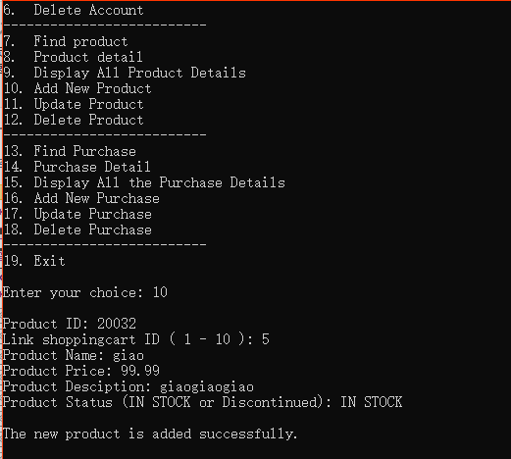

11. Update Product

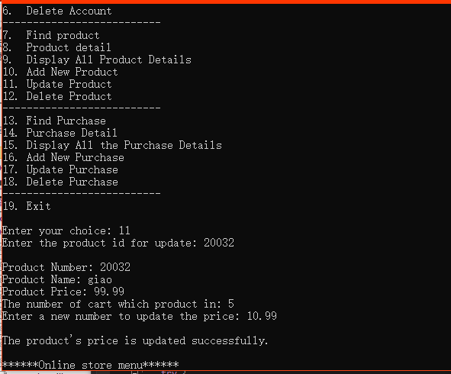

12. Delete Product

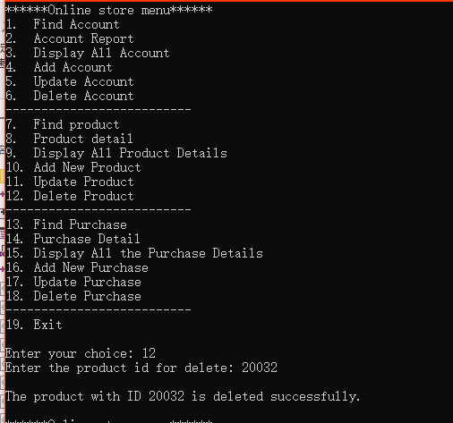

Cpp file functions part for Chirag Mudgil - fixed by Chao Liu

13. Find purchase

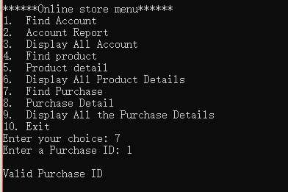

14. Purchase Detail

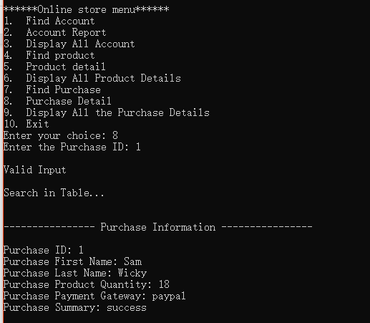

15. Display all the purchase details

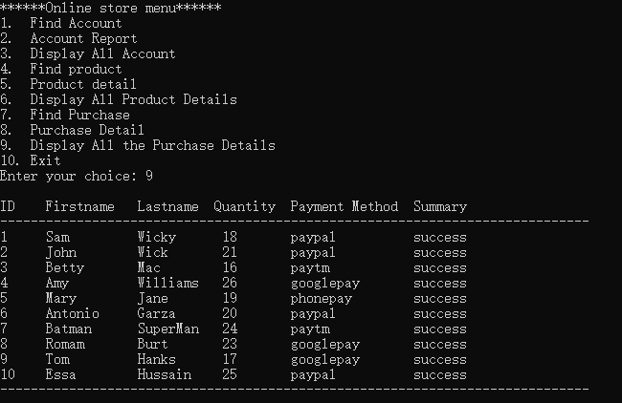

16. Add New Purchase

17. Update Purchase

18. Delete Purchase

//19.Exit function

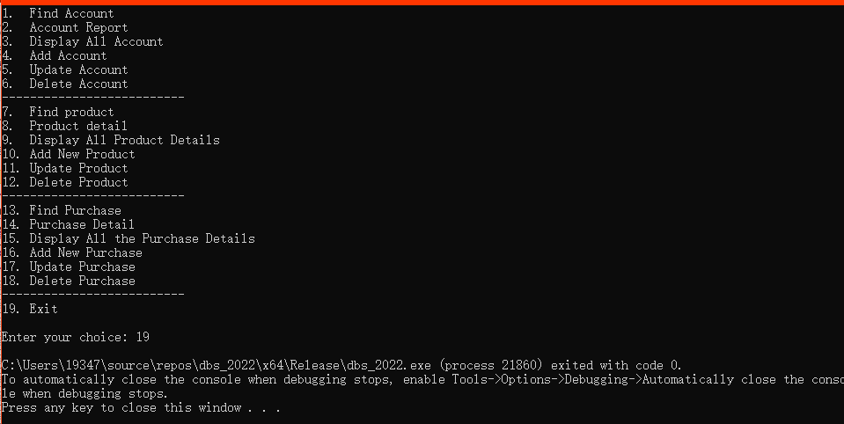

Chi Ming Lai – set up the menu and main void function in the CPP file first and he did find, display, displayall, add, update and delete functions for his table account

Chao Liu – continue with menu and main void function for options 7-12 and he did find, display ,displayall add, update and delete functions for his table product

Chirag Mudgil - continue with menu and main void function for options 16-18 and he did find, display and displayall functions for his table purchase, but not able to make it runnable and fucntion 13 – 15 part is fixed by Chao Liu eventually.